

PRT661
DATA SCIENCE PRACTICE

ASSESSMENT 03
GROUP TECHNICAL DEMONSTRATION AND
PROFESSIONAL PRESENTATION

FORECASTING ASSAULT RATES ACROSS NT REGIONS TO SUPPORT PUBLIC SAFETY RESOURCE PLANNING

Submitted by: Group DAN2 - THEME2
Lecturer: Dr Thuseethan Selvarajah

Student:
Thi Xuan Thanh Tran (Emma) - S389244
Ngoc Anh Nguyen (Will) - S386805
Van Hoi Dang (Hendrick) - S395598
Le Nhat Minh Tran (Thomas) - S390789

Individual Work and Contribution Summary
      - Student Information
Name: Thi Xuan Thanh Tran (Emma)
Student ID: S389244

Individual Project Contribution
My main responsibility in the team is the data processing stage. I cleaned, standardised and merged our three source datasets: NT crime statistics, regional population, and wholesale alcohol supply. This meant aligning everything to the same region-by-month level, handling the SerPro system change and the ANZSOC reclassification, and making sure the merged dataset was ready for modelling. I also took on the monitoring stage, which tracks how the model performs as new data comes in.

The dashboard belongs to another team member, so I didn't build it. I did test it as it developed and gave feedback to help make it clearer and more useful for the audience. Alongside this, I finished drafting the implementation and monitoring sections for our final report, so we have a head start on Assessment 4. For the Assessment 3 presentation, I helped put together the slides.
Supporting Evidence
GitHub repository: https://github.com/HendrickDang/PRT661-DATA-SCIENCE-PRACTICE/commits?author=EmmaTran56
Visualisation:https://github.com/HendrickDang/PRT661-DATA-SCIENCE-PRACTICE/commits/main/eda_plots
Documentation:https://github.com/HendrickDang/PRT661-DATA-SCIENCE-PRACTICE/commits/main/documents
Code:https://github.com/HendrickDang/PRT661-DATA-SCIENCE-PRACTICE/commits/main/End%20to%20End%20pipeline.py
Jira:

Planned Work Before Assessment 4

Before the final submission, I plan to finish the monitoring stage and test it against the latest data. I will also refine my draft sections based on feedback from the assessment 2 and assessment 3 and help the team put together the final report.

Laboratory Completion Evidence of:
- Laboratory 4 - Lab: Storing and Analyzing Data by Using Amazon Redshift
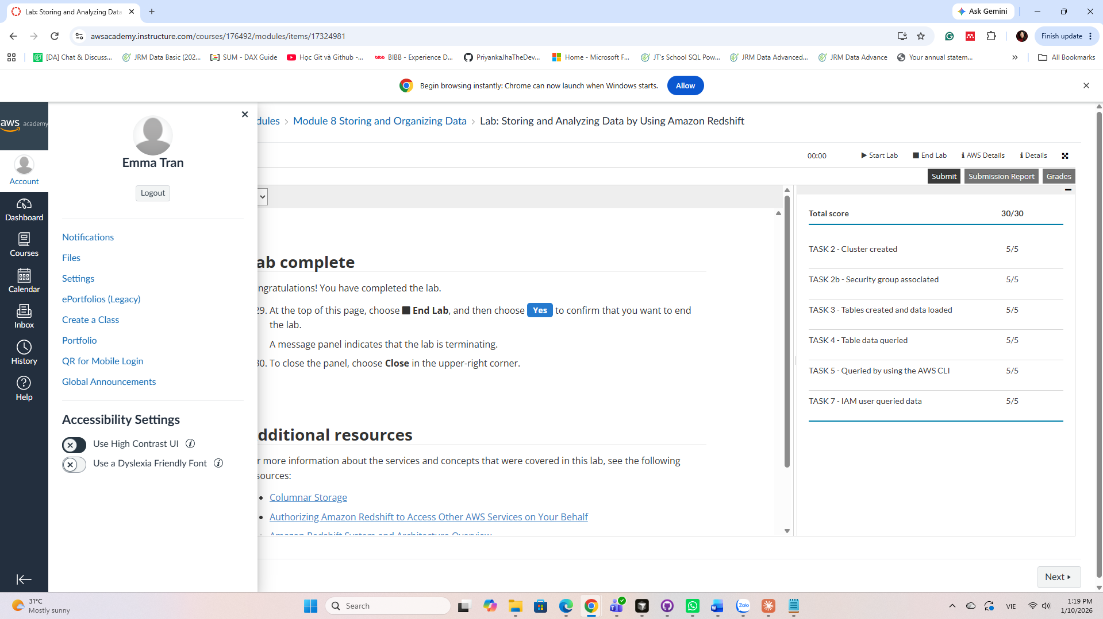

Brief Professional Reflection
Before this lab, I mostly thought of cloud data as files sitting in S3 that you query when you need them, like we did with Athena. Redshift showed me a different approach. I set up a cluster, gave it an IAM role, loaded data from S3 with COPY, and then ran queries on proper tables. What stuck with me was that you have to think about table structure before loading anything, because that decides how easy the analysis is later.

We don't use Redshift in our group project, but this idea still helped. When we combined crime, population and alcohol data, I realised we needed everything at the same level, region by month, before joining. Thinking of the crime counts as the main table and the other datasets as supporting tables made the merging much less messy. It also helped me understand what our cloud migration plan for PFES would actually involve if they ever scale it up.
- Student Information
Name: Van Hoi Dang (Hendrick) - Student ID: S395598
Role: Analytics and Machine Learning
Individual Project Contribution
My role in the team is analytics and machine learning. I own the modelling and the evaluation module, which compares Linear Regression, Ridge, Lasso and XGBoost against two simple baselines using a rolling-origin backtest. The main result is a split recommendation: XGBoost for forecasts one month ahead (RMSE 90.7 per 100,000, about 30% better than seasonal naive) and a 12-month moving average from three months onward.
Since Assessment 2, I added the execution instructions, the model documentation and the workflow diagram to the repository, and updated the change log, README and requirements file so every reported figure can be regenerated. For Assessment 3, I prepared and presented slides 12 to 16: model performance, the backtest, the alcohol supply comparison, technical challenges, and ethics. Before recording, I re-ran the pipeline and checked every figure against its output. This found out-of-date values in the alcohol model table, which I corrected, and wording errors on other slides, which I passed to the team. I also manage the group's GitHub repository and Jira site.
Supporting Evidence
GitHub commits: https://github.com/HendrickDang/PRT661-DATA-SCIENCE-PRACTICE/commits?author=HendrickDang
Evaluation module: https://github.com/HendrickDang/PRT661-DATA-SCIENCE-PRACTICE/commits/main/evaluation.py
Backtest outputs: https://github.com/HendrickDang/PRT661-DATA-SCIENCE-PRACTICE/commits/main/Outputs
Presentation slides: https://github.com/HendrickDang/PRT661-DATA-SCIENCE-PRACTICE/commits/main/Reports/PRT661_Assessment_3.pptx
Jira: https://hendrickdang.atlassian.net/jira/software/projects/SCRUM/boards/1/timeline

Planned Work Before Assessment 4
Before Assessment 4, I plan to save the tuned models with joblib so the dashboard can load them without re-running the pipeline, and to work with Thomas to show the backtest forecasts and prediction intervals in the dashboard. I will also lag the two same-month features found in Will's audit, re-check the single-split results with the provisional months excluded,, finalise the drift thresholds with Emma for the monitoring stage, and write the modelling and evaluation sections of the final report.

Laboratory Completion Evidence of:
Lab 2 (Week 4 materials) - Module 8: Storing and Organizing Data - Lab: Storing and Analyzing Data by Using Amazon Redshift
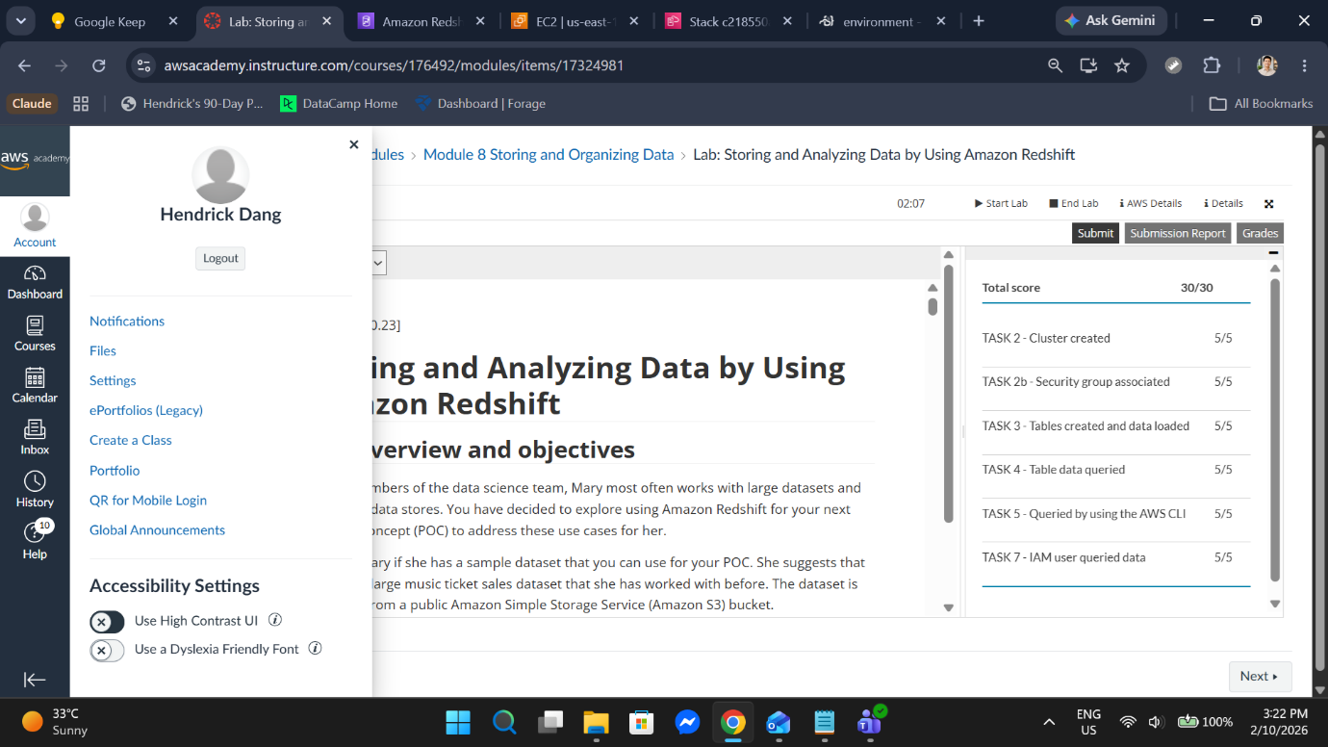
Brief Professional Reflection
In this lab I created a Redshift cluster, attached an IAM role so it could read from S3, defined three tables, loaded them with COPY, and queried them from the console and from the AWS CLI. Two things stood out. First, loading only works when the schema, delimiter and time format are stated exactly, so the structure has to be decided before the data arrives. Second, the Data API is asynchronous: one command submits the query and returns an ID, and a second command fetches the result. I also ran the same query with another user's credentials to confirm that a restricted policy still gave her the access she needed.
We do not use Redshift in our project, but I applied these ideas to the modelling work. Testing as a different user is the same idea as checking that our results reproduce on another machine: when a teammate got a different XGBoost error from mine, when a teammate got a different XGBoost error from mine, I pinned the package versions. The linear models now match exactly, and the small XGBoost difference that remains is documented as a platform effect. Querying through the CLI instead of the console also matches how I built the evaluation module, which writes its results to CSV files, so the report and slides are checked against those files and not copied by hand. Finally, the lab made our cloud plan for PFES more concrete: IAM roles and a security group are what would control who can query the data.

- Student Information

Name: Ngoc Anh (Will) Nguyen - Student ID: S386805
Role: Data Engineering
Individual Project Contribution
My role is data engineering. I own the ingest and storage stages that every later stage depends on: the ingest stage loads the six source files, runs structural checks and logs each run in manifest.json, while the source → raw → processed layout keeps the original downloads untouched.
Since Assessment 2, I built a read-only data lineage and reproducibility audit (pull request #8). It traces every row count from 55,146 raw crime rows to the 696-row model panel (504 train, 192 test), showing that our slides misstate the record count and that training actually starts in 2016, not 2015. A clean-clone rerun with pinned versions reproduced the linear models exactly; XGBoost gave 80.7 instead of 84.5 RMSE per 100k on another platform, but our conclusions hold.
Most importantly, it found that Alcohol_offences and DV_offences are counted from the same month as the target (49% and 64% of target offences, correlation up to 0.97). This is a leakage risk for the single-split results but not for the rolling-origin backtest, and I documented it with a suggested fix. For Assessment 3, I also prepared the first draft of the slide deck and present slides 1 to 6.
Supporting Evidence
GitHub commits: https://github.com/HendrickDang/PRT661-DATA-SCIENCE-PRACTICE/commits?author=ngocanh8585
Data audit (pull request #8): https://github.com/HendrickDang/PRT661-DATA-SCIENCE-PRACTICE/pull/8
Audit report: https://github.com/HendrickDang/PRT661-DATA-SCIENCE-PRACTICE/blob/main/audit/README.md
Ingest stage: https://github.com/HendrickDang/PRT661-DATA-SCIENCE-PRACTICE/commit/4b0049771fd511e687b70527adf292f373e6c654
Jira:

Planned Work Before Assessment 4
Before Assessment 4, I will turn the audit's header-drift check into an automated schema check in ingest, so that drift like the 'Offence type ' and 'Reporting Region' changes already seen between releases stops the pipeline with a clear error instead of silently corrupting the panel. I will then automate the monthly refresh, starting with the January–April 2026 releases. These are needed by Week 10 for the dashboard and drift monitoring, and they give our models a true out-of-sample test. Finally, I will re-run the audit as a release check and write the data engineering and reproducibility sections of the final report.

Laboratory Completion Evidence of:
Laboratory 4 - Module 8 Lab: Storing and Analyzing Data by Using Amazon Redshift
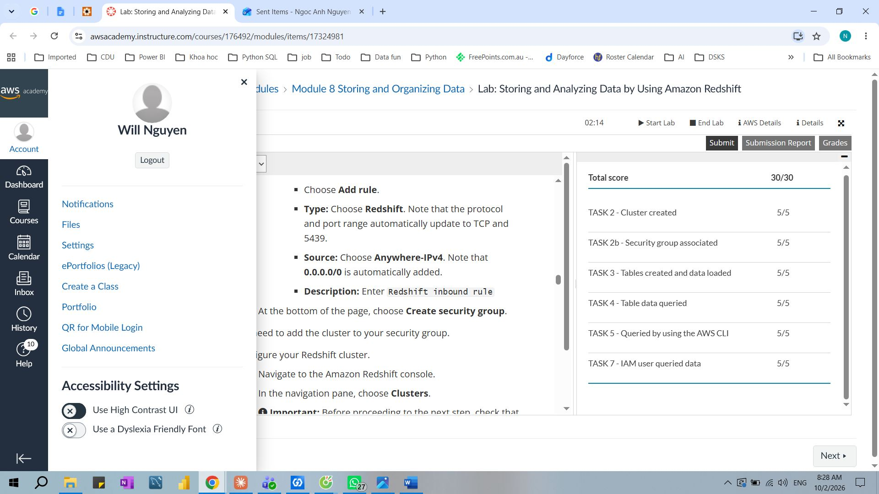

Brief Professional Reflection
In this lab I launched a Redshift cluster, attached an IAM role to read from S3, and loaded tables with COPY. The key lesson was separating storage from the warehouse: S3 files are never edited and tables are always rebuilt from them, so every result traces back to a fixed input.
I applied this directly to my role. Our dataset/source folder works like S3: it is never overwritten, and the processed panel is always rebuilt from it. My audit extends the idea by fingerprinting each source file with a SHA-256 hash and counting rows at every stage, so any figure on our slides traces to an exact input. In a PFES cloud deployment, these folders would map to S3, with IAM controlling access.

- Student Information
Le Nhat Minh (Thomas) Tran – Student ID: S390789

For this project I built the interactive Streamlit decision-support dashboard and co-developed the machine-learning forecasting layer that powers it. On the dashboard side, I created the dual-role portal — a non-technical Administrator Portal for policy makers and police (KPI briefing, an interactive Plotly spatial crime map, a staffing priority matrix, a seasonal surge calendar, a policy intervention simulator, and briefing export) and a technical Data Science Workbench for reviewers (EDA, PCA, feature selection/VIF, hyperparameter curves, Model A vs B, and residual diagnostics) — together with the shared core_data.py caching and training module and a Windows launcher. On the machine-learning side, I co-developed the forecasting suite, building leakage-free feature variants V1–V4 with time-series cross-validation, performing backward-elimination and VIF feature selection, tuning Ridge, Lasso and XGBoost, and wiring the trained model into the dashboard's simulator so it produces live predictions from user-adjusted inputs.
For this project, I built the interactive Streamlit decision-support dashboard and co-developed the machine-learning forecasting layer that powers it. On the dashboard side, I created the dual-role portal which is a non-technical Administrator Portal for policy makers and police (KPI briefing, an interactive Plotly spatial crime map, a staffing priority matrix, a seasonal surge calendar, a policy intervention simulator, and briefing export) and a technical Data Science Workbench for reviewers (EDA, PCA, feature selection/VIF, hyperparameter curves, Model A vs B, and residual diagnostics) r. On the machine-learning side, I co-developed the forecasting suite, building leakage-free feature variants V1–V4 with time-series cross-validation, performing backward-elimination and VIF feature selection, tuning Ridge, Lasso and XGBoost, and wiring the trained model into the dashboard's simulator so it produces live predictions from user-adjusted inputs.
Planned Work For Assessment 4
For Assessment 4 I plan to improve the dashboard from a local prototype into a complete, deployed forecasting tool for PFES: I will add a multi-horizon forecast view (1/3/6/12 months) with prediction intervals and an automatic split-specification switcher (XGBoost at one month, moving average beyond), load serialised joblib models so the dashboard matches the report exactly rather than retraining, deploy the app to Streamlit Community Cloud (fixing the cross-platform Outputs/ path case bug), and align the features with the corrected lagged alcohol/DV model, plus annotate structural breaks and provisional months in the UI — with only the model-serialisation and feature-alignment items depending on the modelling owner, while the rest I can complete independently.
Supporting Evidence
GitHub repository: Commits · HendrickDang/PRT661-DATA-SCIENCE-PRACTICE
Documentation:https://github.com/HendrickDang/PRT661-DATA-SCIENCE-PRACTICE/commits/main/documents
Code:PRT661-DATA-SCIENCE-PRACTICE/app.py at main · HendrickDang/PRT661-DATA-SCIENCE-PRACTICE

Laboratory Completion Evidence of:
Lab 2 (Week 4 materials) - Module 8: Storing and Organizing Data - Lab: Storing and Analyzing Data by Using Amazon Redshift

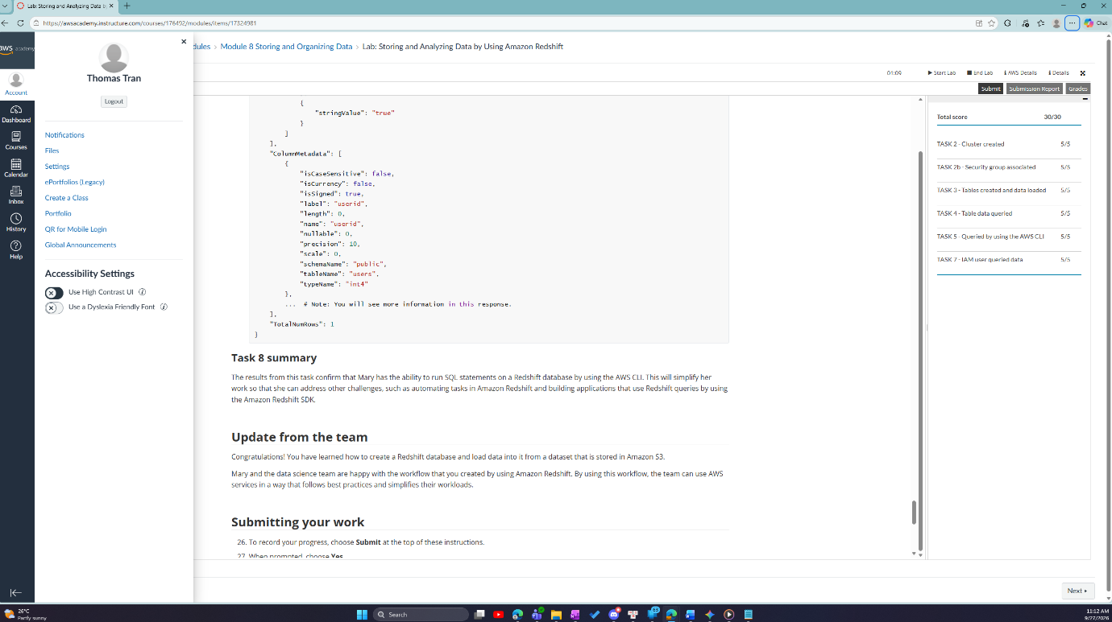

Brief Professional Reflection:
I have never worked with AWS before, this lab has widened my knowledge of Amazon’s products, especially Redshift. Through this lab, I learned how to configure a Redshift cluster, load datasets from Amazon S3, query data, access data via the CLI, and manage access for different user groups. Although AWS is not used in my assessment for this project, the lab opened up my possibilities for me and will definitely be helpful for my future career.

